321 - I'm Britain’s Top Teen DJ!
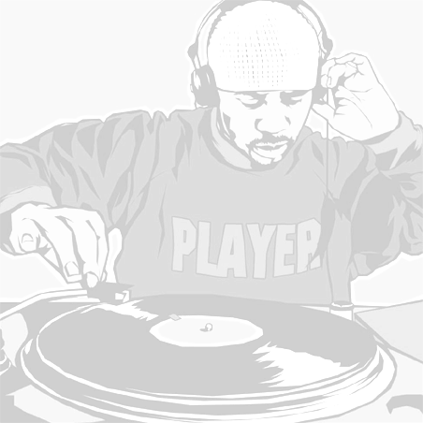
16-year old Joe is officially Britain’s top teen mixmaster! Here’s his spin-tastic story...

When I was 15, I bought my first decks with some money I had been given for Christmas. I probably spent about £ 250 initially on records, a mixer, amp, speakers and headphones. To be honest, mixing came quite naturally to me, as I found it pretty easy to pick up the beat.
Mum was all for it, but Dad wasn’t so keen! I don’t think that most older people get the whole dance music thing – it’s just repetitive noise to them. Plus, Dad was never over the moon when he came in from work to hear me practising, but I guess he got used to it! After a year or so, I started doing mobile discos with a friend. We just took our decks along to friends’ birthday parties and had a laugh, so it was hardly professional!

DJ Funk
Then, about six months ago, I saw a flyer for the Young UK DJ Of The Year competition at a ukclubculture gig in Romford, Essex. It sounded like a good opportunity, so I sent in a tape of my mixing skills. I needed a DJ name, so I chose DJ Funk as that’s the kind of music I play - fresh, funky house!
A week later, a letter arrived telling me I was through the heats! I was over the moon, but I knew I’d have to stay calm as it was only the first step of a really long process. I just kept on practising in between getting through each stage. I usually practise for two or three hours a day anyway!
My regional heat was the first time I played in a real club. I played a set at Zeus in Chelmsford and I loved it! When I got through to the final, I thought I had a chance of doing well, because I'm so dedicated. But when one of the other finalists told me he had improved loads since the last heat, I got quite nervous.

Go bananas
The judges at the final included top DJ's, Carl Cox and Boy George. Carl's always been my inspiration - he's just amazing and it was great to get to meet him. I had a quick chat and he said how impressed he was with me. He was really down to earth and wished me luck for the future, which meant a lot coming from him. When I found out I'd won, I wasn't too shocked as I think I'm good at what I do - I love it and it shows! I gave the crowd what they wanted and everyone went bananas - it was fantastic!
The prize was £ 200 worth of the latest eJay music software titles, two Vestax turntables, a PMC Mixer and PlayStation 2, plus an exclusive contract with Big Bang Management.
They’ve already booked me in at two different clubs to do a couple of gigs next month, at Time and Envy in Romford, and the Liquid Rooms in Luton.
If I could DJ anywhere at all, my dream gig would be at Space in Ibiza, alongside the real DJ-ing masters like Carl Cox, Sacha and Pete Tong. In the meantime, I’m happy just working towards my ambition of DJ-ing full time.

Rock DJ!
Joe’s top tips for DJing success...
- Believe in yourself.
- Practise your technical skills like mad!
- Work on your own individual style – don’t try to copy someone else.
- Do it because you love the music, not the recognition.
- Be flexible and read the crowd – if they want harder music you’ve got to keep it up!
Words to help
amp versterker
repetitive zich herhalend
heats voorrondes
dedicated toegewijd
321 - Vragen bij de tekst:
Lees de tekst I’m Britain’s top teen DJ! Zet achter elke bewering
T (true) of F (false).

- Joe is al jaren bezig met DJ'en.
- Zijn ouders vonden het DJ’en maar niks.
- Joe koos een DJ-naam omdat die paste bij zijn muziek.
- De regionale finale was de eerste keer dat Joe in een echte club draaide.
- Joe was stomverbaasd toen hij de finale had gewonnen.
- Joe won onder andere een geldbedrag van £ 200.
- Joe heeft zelf twee optredens in Luton en Romford geregeld.
- Joe werkt nu full time als DJ.

